The following figure shows the projection of a single point in two images with epipolar line.

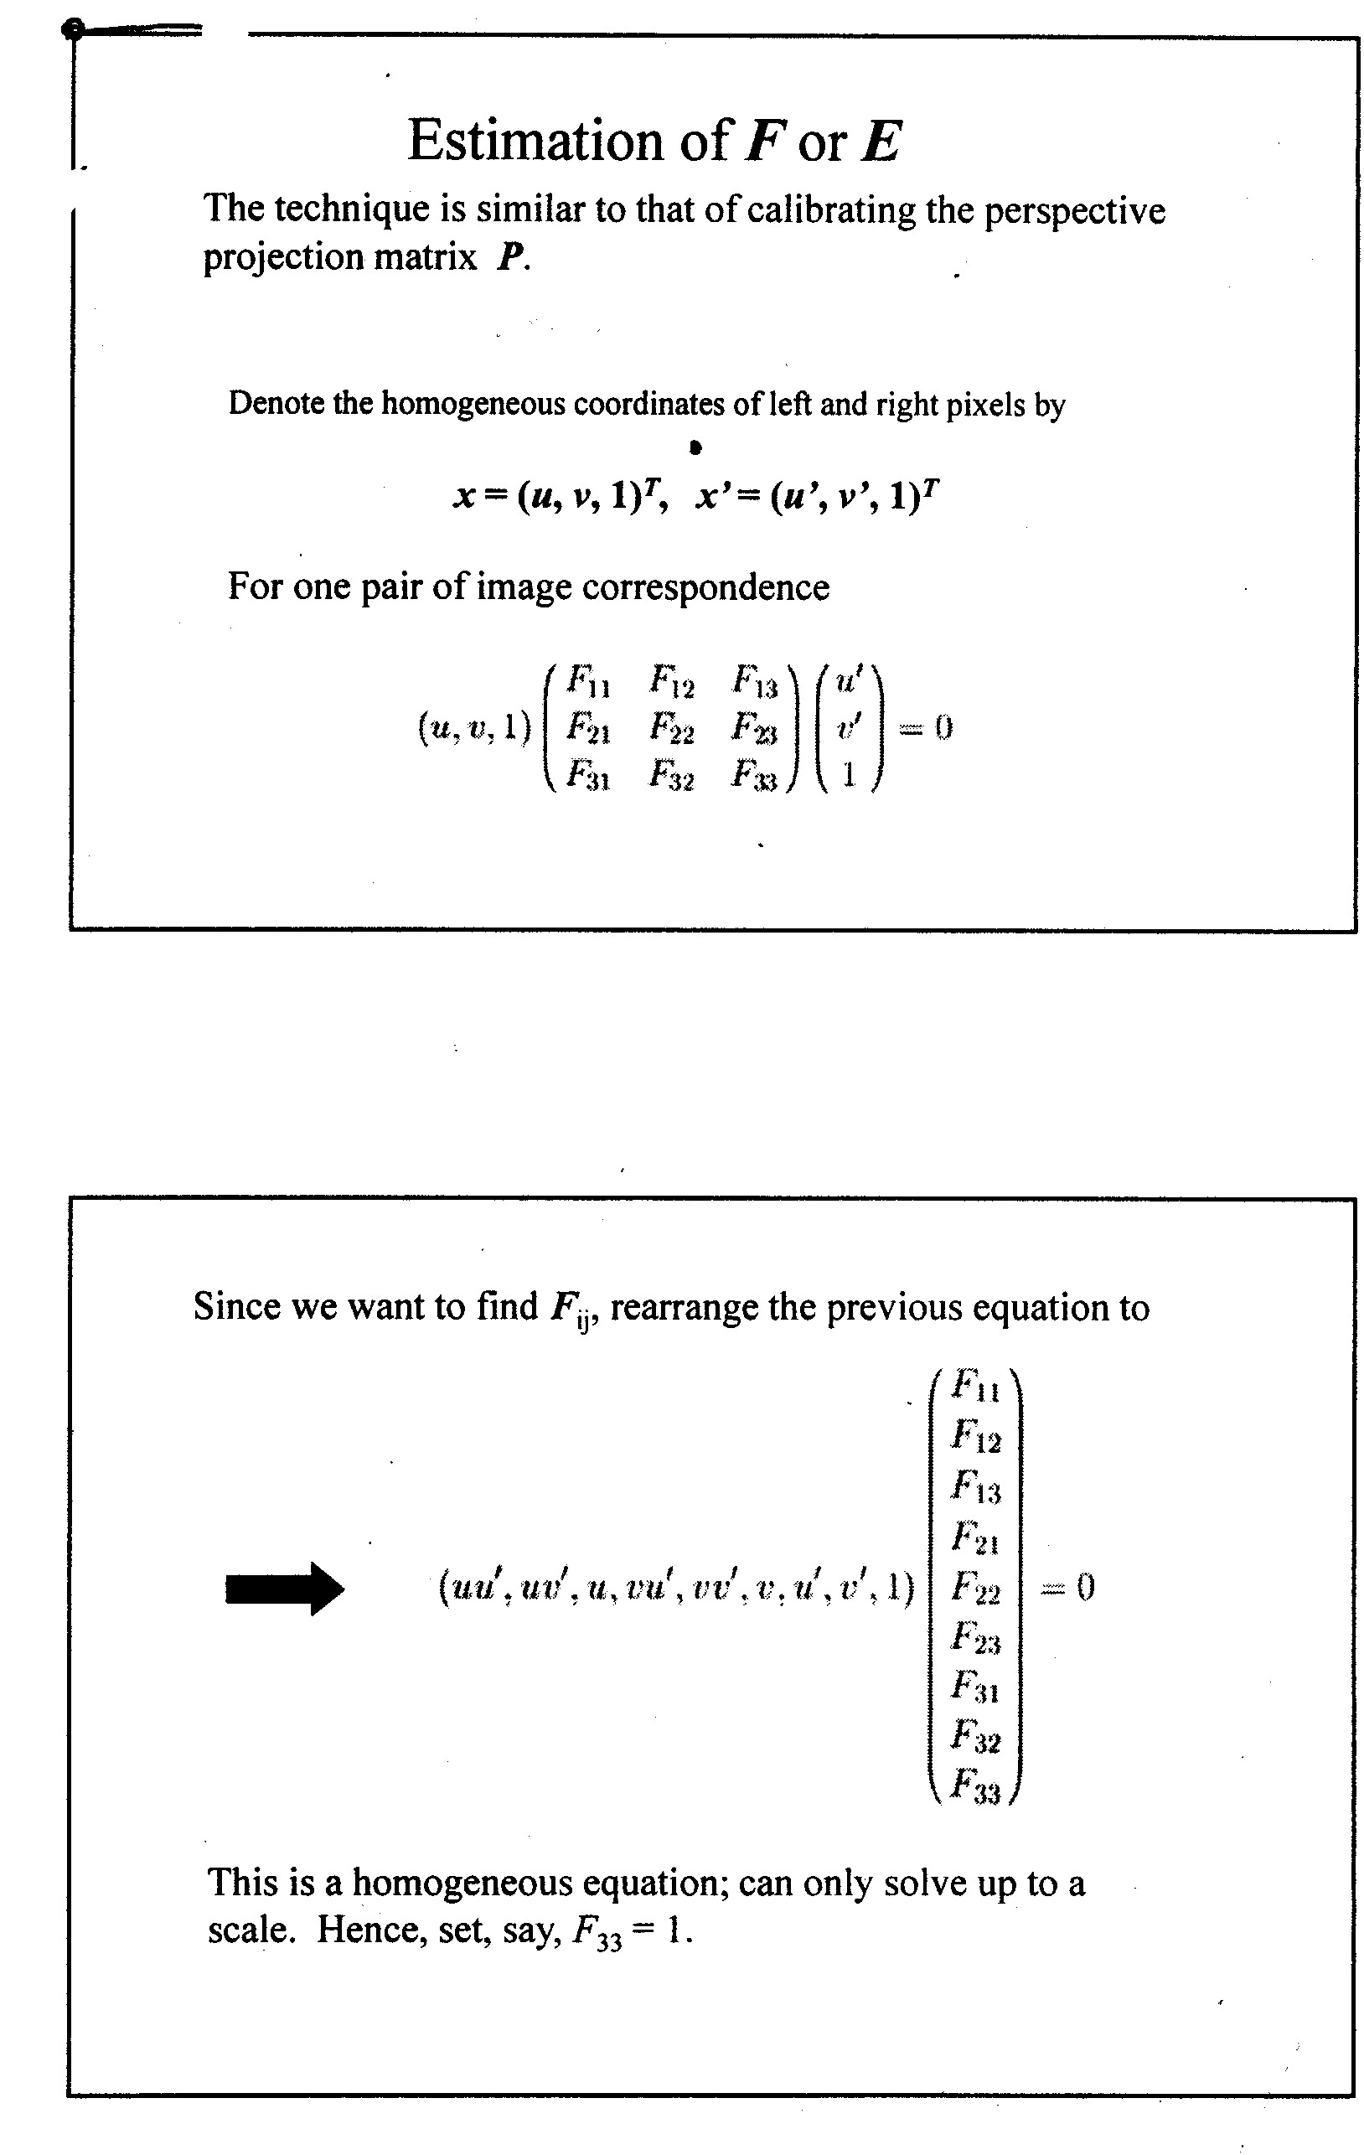

*Epiplolar line*

*v’*

*u’*

*v*

*u*

***x’***

***x***

*Left image*

*Right image*

Fundamental Matrix

(1)

